# Virtual Room

Emre Unal CS 4331 – Virtual Reality

# Video Demo

# Live Demo

<https://emreunal93.github.io/emreunal.github.io/>

# Features

* Virtual living room that is developed with A-Frame framework
* Interactable with some specific object
* Mobile compatible
* User has control over the any lightning in the room

All interactions with objects can be done in;

* On pc: by clicking on the objects
* On mobile: hovering over the objects

Virtual-Room when lights are on/off

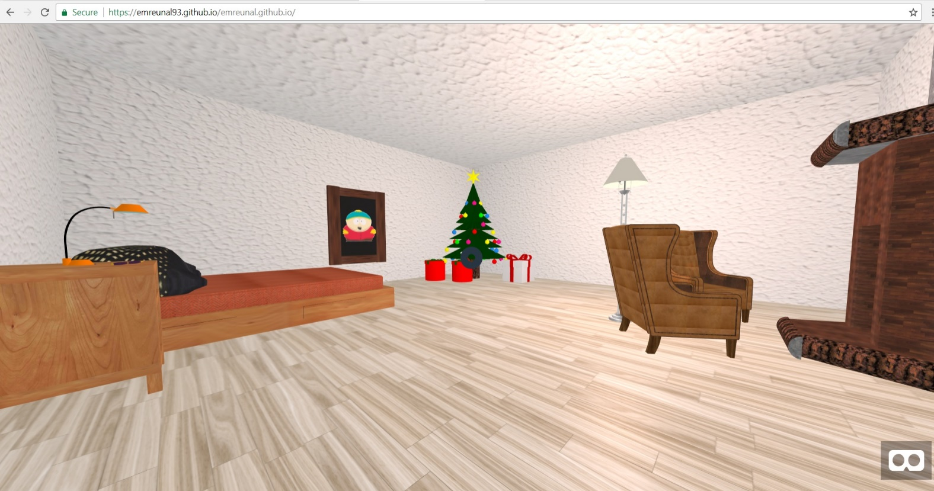

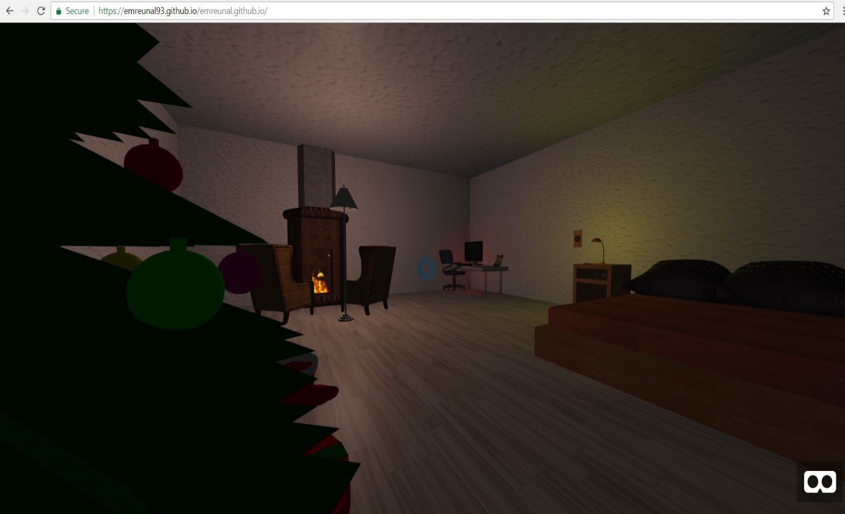

Interacting with computer

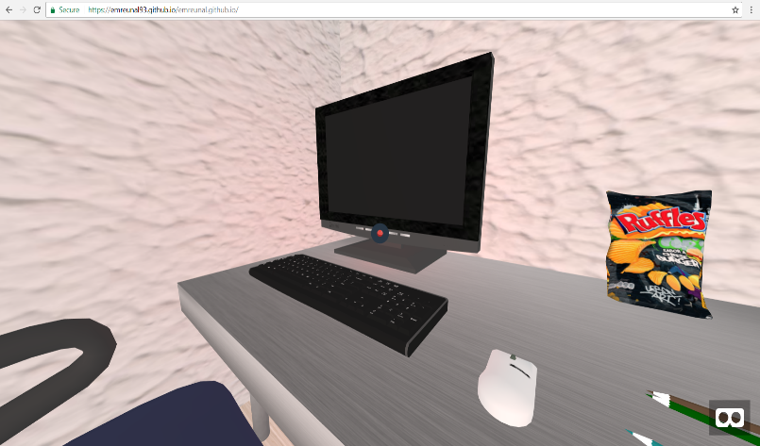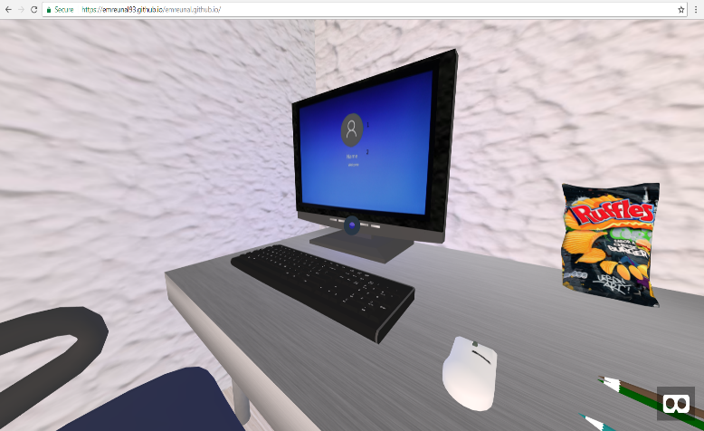

When clicked on the button of the monitor, it triggers a windows opening/closing sound, and also changes the color of the button (Blue when it is on / Red when monitor is off).

Interacting with lights

User has the ability to control the lightning of the virtual room. In addition to that, all lightning sources cause shadow effect on the objects.

* Desk Lamp

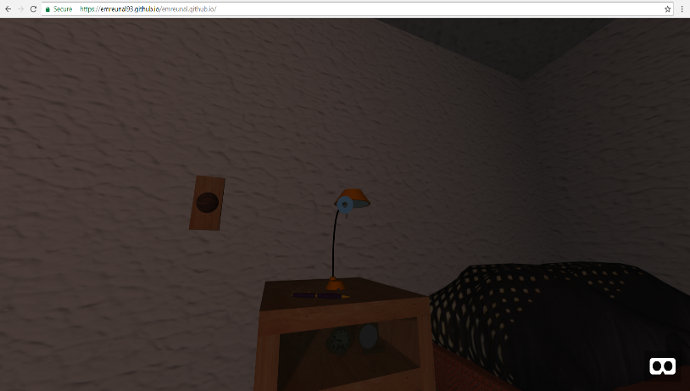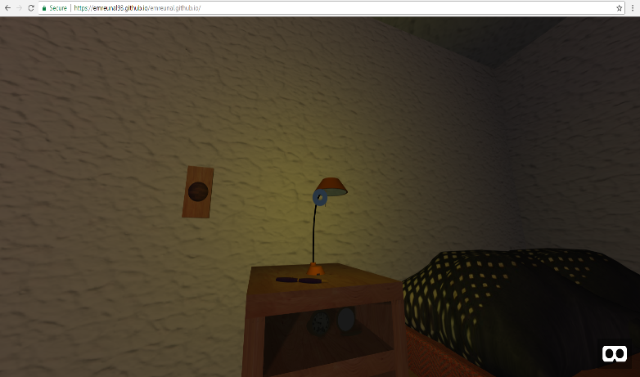On Off

Shadow effect on drawer caused by desk lamp and floor lamp

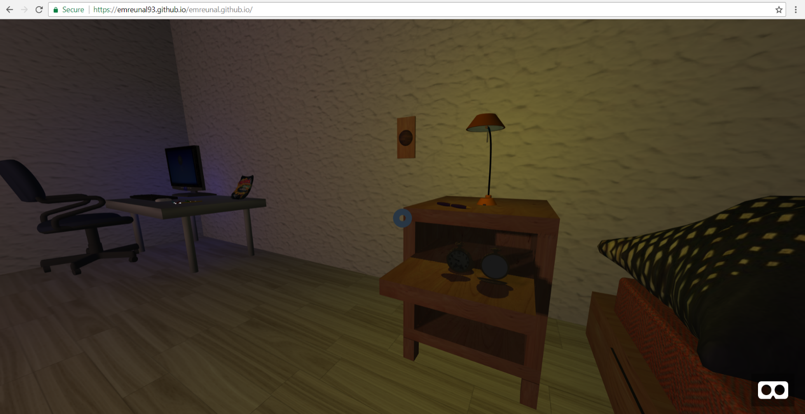

* Floor Lamp

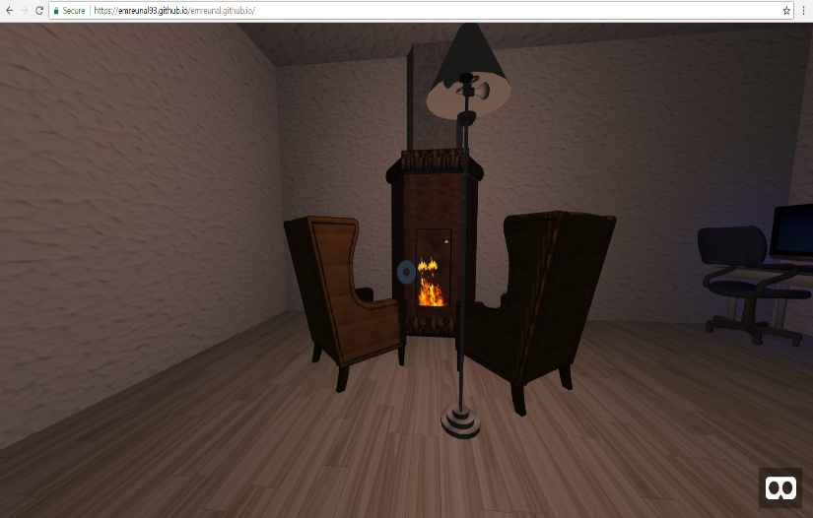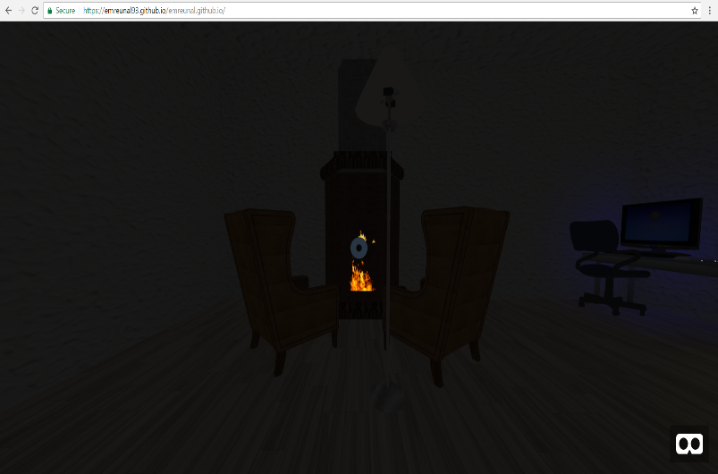On Off

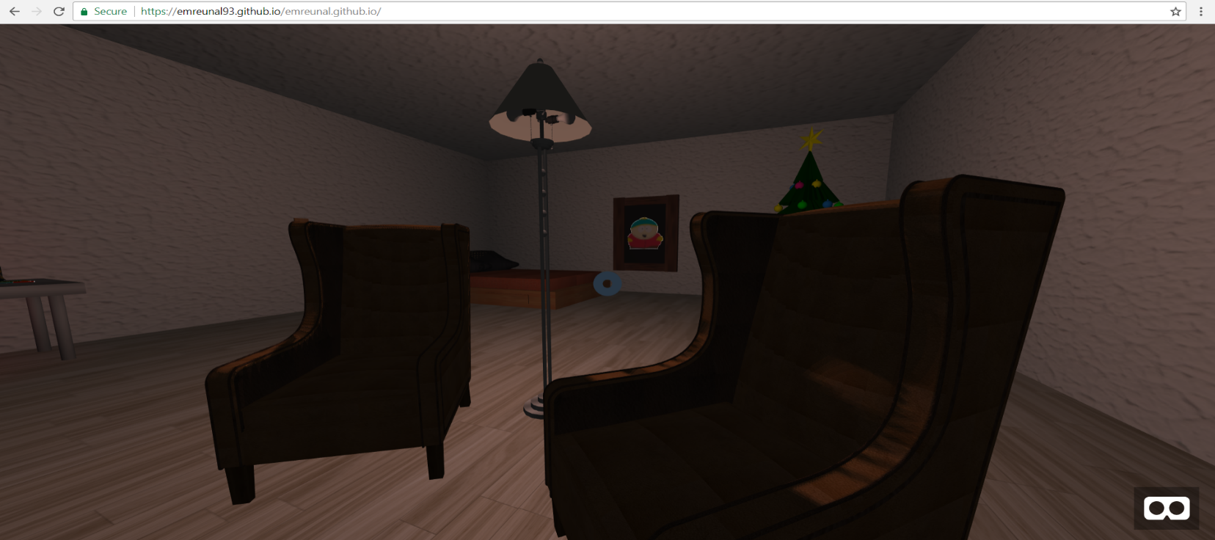Floor lamp causes shadow effect on chairs

* Room light

Room light can be switched by clicking the button on the wall

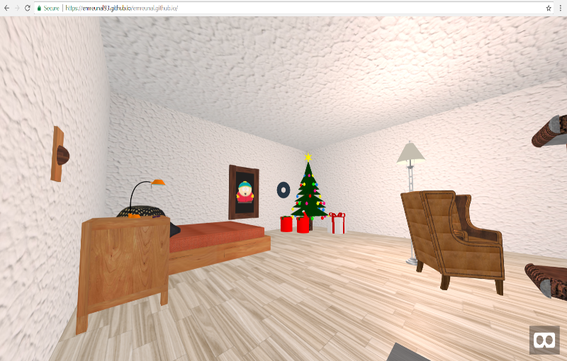On Off

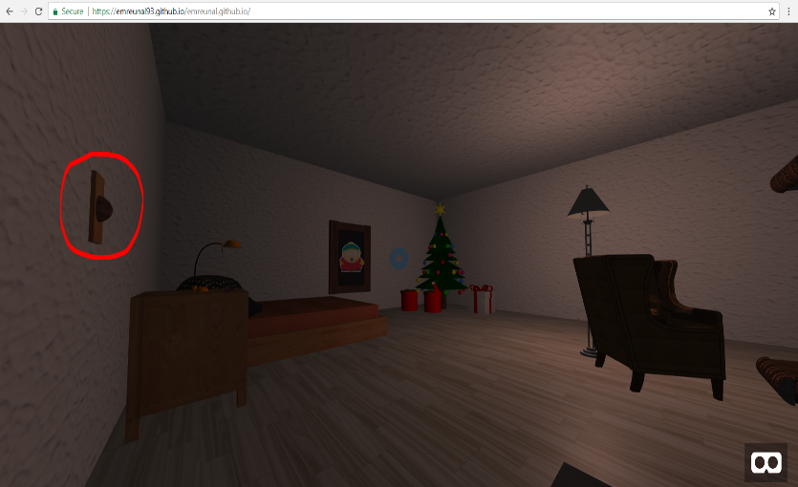

Interacting with drawer

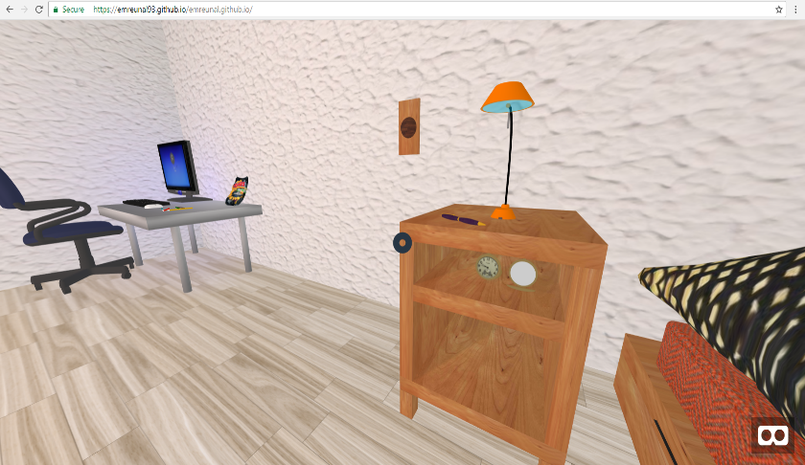 User can interact with drawer by clicking on it.

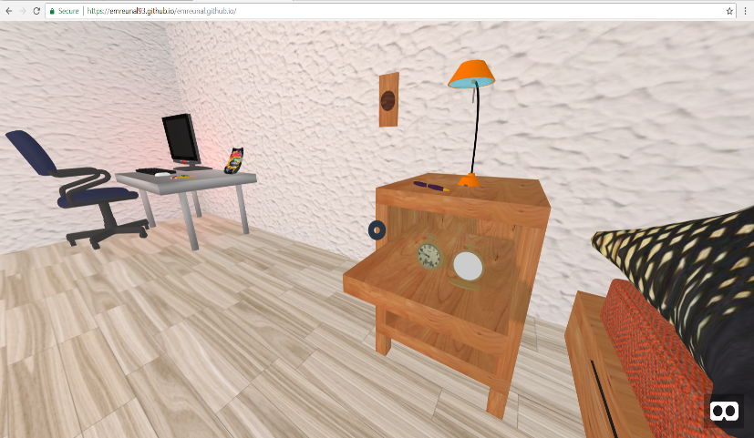

Interacting with picture

User can interact with Eric Cartman’s picture on the wall by clicking on it which triggers a *.wav sound file and Eric Cartman says hi to user.

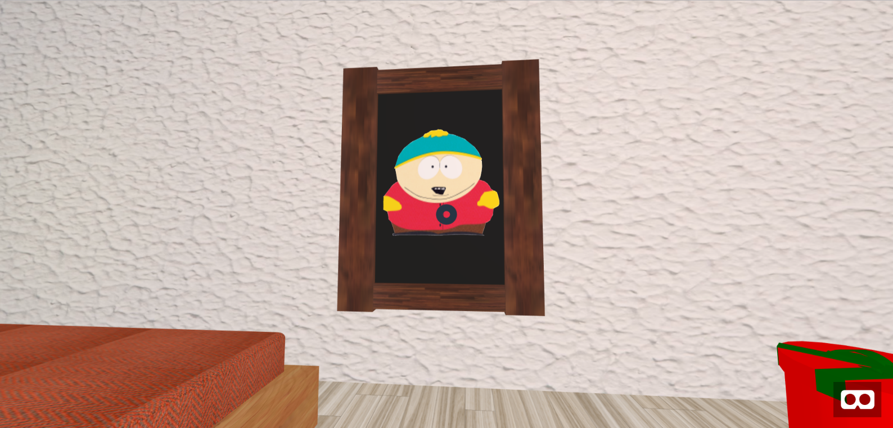

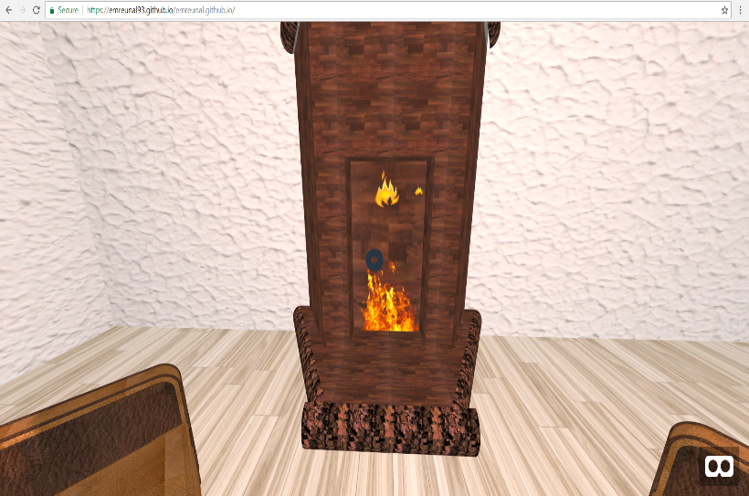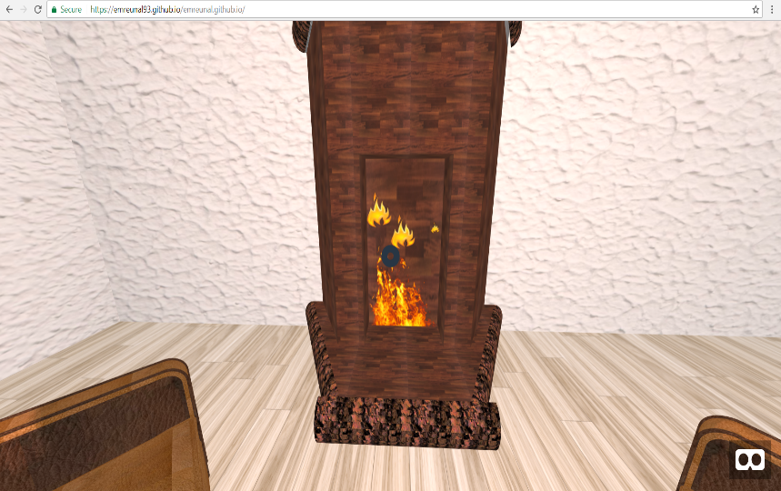Animated Fireplace